

Subject Name & Code :- Management (315301). Academic Year:-2025-2026. Course Name:- C.O. Semester:- Sixth.

A Study on:
Energy Management In Industries.
Microproject report
By the Student.

Sr.n o. | Roll no. (Sem-VI) | Name of student | Enrollment No. | Seat no. (Sem-VI)
1 | 11 | Bandawane Yash Mahesh | 23112090341

Under The Guidance of:- Mrs.Madhuri Ghawat.
In.
Third Year of Diploma program in computer engineering of Maharashtra State Board Of Technical Education, Mumbai.
AT.
Shivajirao’s Jondhale Polytechnic Asangaon (E).



Maharashtra State Board of Technical Education Mumbai
Certificate

This is to certify that Mr.Bandawane Yash Mahesh Roll No.11 of Sixth Semester of COMPUTER ENGINEERING Diploma Programme in Computer Engineering at Shivajirao .S. Jondhale Polytechnic Asangaon has completed the Micro Project satisfactorily in the subject Management in the academic year 2025-26 as per the MSBTE Prescribed of ‘K’ scheme.

Place: ASANGAON Enrollment No: 23112090341
Date: / /2026 Exam seat No:

Subject Teacher Head of Department Principle

Seal of Institute

INDEX

Sr.no | Topics Covered
1 | Acknowledgment
2 | Abstract
3 | Introduction
4 | Meaning Of Energy Management
5 | Objectives of Energy Management
6 | Principles of Energy Management
7 | Sources Of Industrial Energy
8 | Energy Consumption Pattern In Industries
9 | Energy Audit
10 | Energy Conservation Techniques
11 | Energy-Efficient Technologies
12 | Renewable Energy In Industries
13 | Risk Analysis
14 | Test Cases Report
15 | Conclusion & References

Acknowledgment
It gives me great pleasure to submit this project report on “Energy Management in Industries.” I express my sincere thanks to my project guide, Respected Mrs. Madhuri Ghawat, Department of Computer Engineering, for her constant support and valuable guidance provided throughout the preparation of this report. Her continuous encouragement, suggestions, and insights have been a great source of inspiration for me.

I would also like to express my honest gratitude to Respected Mrs. Ashwini Dhage, Head of the Department of Computer Engineering, for her guidance, valuable suggestions, and constant support during the completion of this project work.

I take this opportunity to acknowledge the contribution of all faculty members of the Department of Computer Engineering for their cooperation and assistance during the development of this project.

I am also very thankful to Respected Principal Dr. Anwesh K. Vikrunwar for being a constant source of motivation and encouragement to successfully complete this work.

Last but not the least, I express my heartfelt gratitude to my family members for their continuous encouragement and moral support throughout the completion of this project.

Name of Student:
Yash Mahesh Bandawane.

Abstract
Energy Management in Industries is an important aspect of modern industrial operations that focuses on the efficient use, monitoring, and conservation of energy resources. Industries consume a significant amount of energy in the form of electricity, fuel, steam, and other resources for production and operational activities. Effective energy management helps in reducing operational costs, improving productivity, and minimizing environmental impact.

This microproject focuses on the concept, techniques, and implementation of Energy Management in Industries using various management principles and strategies. The main objective of this project is to understand how industries can monitor energy consumption, reduce wastage, improve efficiency, and adopt sustainable practices.

The project includes the study of major areas such as energy sources used in industries, energy auditing, energy conservation techniques, energy-efficient technologies, renewable energy integration, and the role of an energy manager. It also explains the importance of Energy Management Systems (EnMS) and standards like ISO 50001 in maintaining systematic energy control.

Different methods such as energy monitoring, load management, preventive maintenance, and process optimization are discussed to analyze how industries can reduce energy losses. The report also highlights the benefits of energy management, including cost reduction, improved environmental performance, compliance with government regulations, and enhanced corporate reputation.

This project emphasizes how proper energy management not only improves industrial efficiency but also supports sustainable development and long-term organizational growth.

Introduction
In today’s industrial era, energy has become one of the most important resources for production and business operations. Industries require large amounts of electricity, fuel, steam, and other forms of energy to run machines, operate equipment, and maintain production processes. As energy costs are continuously increasing and environmental concerns are growing, effective Energy Management has become essential for every industry.

Energy Management is the process of planning, monitoring, controlling, and conserving energy in an organization to reduce consumption without affecting productivity. It focuses on improving energy efficiency, minimizing wastage, reducing operational costs, and promoting sustainable development. Proper energy management not only improves profitability but also helps industries comply with government regulations and environmental standards.

Industrial sectors such as manufacturing, cement, steel, textile, chemical, and automobile industries consume a significant portion of total energy. If energy is not managed properly, it leads to higher expenses, resource depletion, and environmental pollution. Therefore, industries must adopt systematic approaches such as energy auditing, performance monitoring, preventive maintenance, and implementation of energy-efficient technologies.

Energy Management includes various activities such as identifying major energy-consuming areas, analyzing energy usage patterns, setting energy-saving targets, and implementing corrective measures. It also involves the use of renewable energy sources, modern control systems, and standards like ISO 50001 to ensure continuous improvement in energy performance.

This project focuses on studying the concept, principles, and practical applications of Energy Management in Industries. The objective is to understand how industries can reduce energy consumption, improve operational efficiency, and achieve sustainable growth through proper management practices.

Hence, this microproject provides practical knowledge of Management concepts and their application in the field of industrial energy conservation and efficiency improvement.

Meaning Of Energy Management
Energy Management refers to the systematic planning, monitoring, controlling, and efficient use of energy resources in an organization, especially in industrial sectors, to achieve maximum productivity with minimum energy consumption. It involves managing different forms of energy such as electricity, fuel, steam, gas, and renewable sources in a way that reduces wastage and improves overall efficiency without affecting the quality of production or safety of operations.

In industries, energy is considered one of the most important and costly inputs required for manufacturing processes, machine operations, heating, cooling, lighting, and transportation. Therefore, managing energy effectively has become a necessity rather than a choice. Energy management ensures that energy is used in a planned and optimized manner so that unnecessary consumption and losses can be avoided. It focuses not only on reducing energy usage but also on improving energy performance through better technologies, improved operational practices, and proper maintenance of equipment.

Energy management includes activities such as analyzing energy consumption patterns, identifying major energy-consuming areas, setting targets for energy conservation, implementing energy-saving measures, and continuously monitoring performance. It also involves the use of modern tools and techniques such as energy audits, automated control systems, and energy management software to track and control energy usage in industries.

Another important aspect of energy management is cost control. Since energy expenses contribute significantly to overall production costs, efficient management helps industries reduce operational expenses and improve profitability. It also enhances the reliability of production processes by ensuring a stable and uninterrupted energy supply.

Energy management is also closely related to environmental protection and sustainable development. Excessive and unplanned use of energy leads to environmental pollution, greenhouse gas emissions, and depletion of natural resources. By promoting energy conservation and the use of renewable energy sources such as solar and wind energy, industries can reduce their environmental impact and contribute to a greener future.

Moreover, energy management encourages employee participation and awareness in energy- saving practices. It creates a culture within the organization where every individual understands the importance of conserving energy and using resources responsibly. This collective effort leads to better implementation of energy-saving strategies and long-term benefits.

Thus, energy management is a continuous and organized process that aims to improve energy efficiency, reduce costs, minimize environmental impact, and ensure sustainable industrial growth. It plays a vital role in modern industries by supporting productivity, competitiveness, and responsible resource utilization.

Objectives Of Energy Management
The main objective of energy management in industries is to ensure the efficient and optimum use of energy resources without affecting production, productivity, quality, or safety. Energy is one of the most important inputs in industrial operations, and its proper management directly influences the overall performance and profitability of an organization. Industries consume large amounts of electricity, fuel, steam, and other forms of energy in manufacturing processes, machine operations, lighting, heating, cooling, and transportation. Therefore, the primary aim of energy management is to reduce unnecessary energy consumption and ensure its effective utilization.

One of the key objectives of energy management is to minimize energy wastage by identifying areas where energy losses occur and implementing corrective measures. This includes monitoring energy consumption patterns, analyzing the performance of machines and equipment, and improving operational practices. By reducing energy losses, industries can lower operational costs and improve overall efficiency. Energy management also aims to enhance the productivity of industries by ensuring that energy is supplied and used in a reliable and efficient manner.

Another important objective is cost reduction. Energy expenses form a significant portion of industrial operational costs. Effective energy management helps industries control these costs by adopting energy-efficient technologies, optimizing production processes, and implementing preventive maintenance programs. This results in better financial performance and increased competitiveness in the market.

Energy management also focuses on environmental protection. Excessive use of energy resources leads to pollution, greenhouse gas emissions, and depletion of natural resources. By promoting the use of renewable energy sources such as solar and wind energy and adopting eco-friendly technologies, industries can reduce their environmental impact and contribute to sustainable development.

In addition, energy management aims to improve equipment performance and extend the lifespan of machinery. Efficient energy use reduces wear and tear, prevents overheating, and ensures smooth operations. It also encourages employee awareness and participation in energy conservation activities, making energy management a shared responsibility within the organization.

Thus, the overall objective of energy management is not only to conserve energy but also to improve efficiency, reduce costs, protect the environment, and support long-term industrial growth and sustainability.

Principles of Energy Management
Energy management in industries is based on a set of systematic principles that help organizations use energy efficiently and responsibly. These principles guide industries in planning, monitoring, and controlling energy consumption to achieve maximum output with minimum energy usage. The effective implementation of these principles ensures sustainable industrial development and economic benefits.

The first principle of energy management is regular monitoring and measurement of energy consumption. Industries must track how energy is used in different processes, departments, and equipment. This helps in identifying high energy-consuming areas and taking necessary corrective actions. Without proper monitoring, it becomes difficult to control energy wastage and improve efficiency.

Another important principle is the identification and elimination of energy losses. Energy losses may occur due to inefficient machines, poor maintenance, leakage, improper insulation, and outdated technologies. By identifying such issues and implementing improvements, industries can significantly reduce energy wastage and improve overall performance.

Efficient utilization of energy resources is also a fundamental principle. Industries must ensure that the right type and amount of energy is used for the right purpose. This includes using energy-efficient motors, automated control systems, and modern technologies that consume less power while providing better performance.

Preventive maintenance is another key principle of energy management. Regular maintenance of machines and equipment ensures smooth operation, reduces breakdowns, and prevents energy losses. Well-maintained equipment operates more efficiently and consumes less energy compared to poorly maintained systems.

Employee awareness and participation also play a significant role in energy management. Workers and staff should be trained to follow energy-saving practices such as switching off unused equipment, reporting energy leaks, and using resources responsibly. Energy management becomes more effective when all employees actively participate in conservation efforts.

The use of renewable and sustainable energy sources is an important principle in modern industries. Adoption of solar energy, wind energy, and biomass reduces dependence on conventional fuels and helps protect the environment. It also supports long-term energy security.

Continuous improvement is another essential principle of energy management. Industries must regularly evaluate their energy performance, set new targets, and implement improved strategies. This ensures that energy management practices evolve with technological advancements and changing industrial needs.

Therefore, the principles of energy management provide a structured approach for industries to reduce energy consumption, improve efficiency, minimize costs, and contribute towards environmental sustainability and responsible industrial development.

Sources Of Industrial Energy
Industries require a large amount of energy to carry out manufacturing processes, operate machinery, maintain production systems, and support various operational activities such as heating, cooling, lighting, and transportation. Energy is considered one of the most important inputs in industrial development, and its availability and efficient utilization directly affect productivity, cost, and performance. The sources of industrial energy can be broadly classified into conventional and non-conventional sources, depending on their availability, usage, and environmental impact.

Conventional sources of industrial energy include electricity, coal, diesel, natural gas, and furnace oil. Electricity is one of the most widely used forms of energy in industries as it powers machines, equipment, lighting systems, and automated production lines. It is essential for operating motors, compressors, pumps, and control systems. Coal is another major energy source, especially in heavy industries such as steel, cement, and power generation plants. It is mainly used for heating, steam generation, and furnace operations. Diesel and furnace oil are commonly used in generators, boilers, and heavy machinery, particularly in industries where continuous power supply is required. Natural gas is also widely used for heating, cooking, and power generation because it is cleaner and more efficient compared to other fossil fuels.

Steam is another important form of energy used in industries. It is generated using boilers and is commonly used for heating, sterilization, drying, and various chemical processes. Steam plays a vital role in industries such as textile, food processing, pharmaceuticals, and chemicals. Similarly, compressed air is also used as an energy source in industrial operations for running pneumatic tools, machines, and automation systems.

In recent years, non-conventional and renewable sources of energy have gained importance due to increasing environmental concerns and depletion of natural resources. Solar energy is widely used in industries for heating water, lighting, and power generation through solar panels. Wind energy is used to generate electricity in areas where wind resources are available. Biomass energy, derived from organic materials such as agricultural waste and wood, is used in certain industries for heat and power generation. Hydropower is another renewable source that provides electricity for industrial operations in areas near water resources.

The selection of energy sources in industries depends on several factors such as cost, availability, reliability, environmental impact, and the nature of industrial processes. Many industries use a combination of conventional and renewable energy sources to ensure continuous operations and reduce dependence on fossil fuels.

Efficient utilization of these energy sources is very important for industrial growth and sustainability. Proper energy management helps in reducing energy consumption, lowering production costs, minimizing environmental pollution, and improving overall efficiency. Therefore, understanding and managing the various sources of industrial energy is essential for achieving long-term industrial development and environmental protection.

Conventional Sources
- Electricity
- Coal
- Diesel
- Natural Gas
- Furnace Oil

Non-Conventional Sources
- Solar Energy
- Wind Energy
- Biomass Energy
- Hydropower

These sources are used depending on industrial requirements and availability.

Energy Consumption Pattern In Industries
Energy consumption in industries refers to the way energy is used in different industrial activities such as production processes, machine operations, heating, cooling, lighting, and transportation. Industries are among the largest consumers of energy, and their consumption patterns vary depending on the type of industry, scale of production, technology used, and operational requirements. Understanding the energy consumption pattern is essential for effective energy management, as it helps identify areas where energy is heavily used and where conservation measures can be applied.

In most industries, a major portion of energy is consumed in operating machinery and equipment. Electric motors, compressors, pumps, conveyors, and production machines require continuous power supply to function efficiently. These machines often run for long hours, leading to high electricity consumption. Heavy industries such as steel, cement, and chemical plants consume even more energy due to the need for high-temperature operations, melting, heating, and mechanical processing.

Heating and cooling systems also account for a significant share of industrial energy consumption. Boilers, furnaces, and kilns are used for generating heat and steam required in production processes. Similarly, cooling systems and refrigeration units are used in industries such as food processing, pharmaceuticals, and chemical manufacturing to maintain product quality and safety. These systems consume large amounts of electricity and fuel.

Lighting systems form another part of the energy consumption pattern in industries. Large industrial buildings, warehouses, and production areas require continuous lighting for safe and efficient operations. Traditional lighting systems consume more power, whereas modern LED lighting helps reduce energy consumption significantly.

Energy is also consumed in material handling and transportation within industries. Equipment such as forklifts, cranes, and automated conveyor systems require electricity or fuel to operate. In addition, backup power systems such as diesel generators are used during power failures, contributing further to energy consumption.

Different industries show different patterns of energy usage. For example, the steel and cement industries consume more thermal energy, while textile and electronics industries depend more on electrical energy. Chemical and pharmaceutical industries require both electrical and thermal energy for processing, mixing, heating, and cooling operations.

Energy consumption patterns are influenced by factors such as production capacity, technology used, age of equipment, maintenance practices, and level of automation. Outdated machines and inefficient systems consume more energy compared to modern energy-efficient equipment. Poor maintenance also leads to energy losses and increased consumption.

By studying energy consumption patterns, industries can identify high energy-consuming areas and take corrective measures such as upgrading equipment, improving insulation, optimizing processes, and implementing energy-saving techniques. This helps in reducing operational costs, improving productivity, and supporting environmental sustainability.

Therefore, analyzing the energy consumption pattern in industries is a crucial step in energy management. It helps organizations understand how energy is used, where it is wasted, and how it can be conserved for better efficiency and long-term industrial growth.

Energy consumption varies from industry to industry. Major energy-consuming sectors include:

- Steel industry
- Cement industry
- Textile industry
- Chemical industry
- Automobile industry

Energy is mainly used in:

- Heating and cooling
- Machine operations
- Lighting systems
- Production processes
- Transportation

Energy Audit
Energy Audit is a systematic and scientific process of analyzing, monitoring, and evaluating energy consumption in an industry or organization to identify opportunities for energy conservation and improve overall efficiency. It helps industries understand how energy is being used, where it is being wasted, and what steps can be taken to reduce consumption without affecting productivity or quality. Energy audit plays a vital role in energy management as it provides a clear picture of energy usage patterns and helps in making informed decisions regarding energy-saving measures.

In industries, a large amount of energy is consumed in various processes such as machine operations, heating, cooling, lighting, and transportation. Without proper analysis, it becomes difficult to identify areas where energy losses occur. An energy audit helps in detecting inefficiencies in equipment, processes, and operational practices. It provides recommendations to improve energy performance by adopting better technologies, modifying processes, and implementing energy conservation techniques.

The main purpose of an energy audit is to reduce energy costs and improve the efficiency of industrial operations. It helps industries minimize energy wastage, optimize resource utilization, and enhance productivity. Energy audits also support environmental protection by reducing greenhouse gas emissions and promoting sustainable use of energy resources.

Energy audits are generally carried out in two stages. The first stage is the preliminary energy audit, which involves a simple review of energy consumption patterns, utility bills, and major energy-consuming areas. This type of audit provides a basic understanding of energy usage and identifies obvious areas where energy savings can be achieved. The second stage is the detailed energy audit, which involves in-depth analysis, measurement of energy parameters, and detailed study of equipment performance. It provides comprehensive recommendations for improving energy efficiency.

The process of conducting an energy audit involves several steps. It begins with data collection related to energy consumption, such as electricity bills, fuel usage, and operating hours of equipment. This is followed by inspection of machines and systems to identify energy losses. Measurements and analysis are then performed using specialized instruments to evaluate performance and efficiency. Based on the findings, suggestions and recommendations are provided to reduce energy consumption. Finally, these measures are implemented and monitored to achieve desired results.

Energy audits also help industries comply with government regulations and energy conservation policies. In many countries, large industries are required to conduct regular energy audits to ensure efficient use of resources. This promotes awareness about energy conservation and encourages industries to adopt modern energy-efficient technologies.

Overall, energy audit is an essential tool for improving energy efficiency in industries. It not only helps in reducing operational costs but also improves equipment performance, enhances productivity, and supports environmental sustainability. By regularly conducting energy audits, industries can ensure better energy planning, efficient resource utilization, and long-term economic benefits.

Energy Audit is the process of analyzing energy consumption in an industry to identify energy- saving opportunities.

Types of Energy Audit
- Preliminary Energy Audit
- Detailed Energy Audit

Steps in Energy Audit
- Data collection
- Energy usage analysis
- Identification of losses
- Recommendation of improvements
- Implementation of measures

Energy Conservation Techniques
Energy conservation techniques refer to the methods and practices adopted by industries to reduce energy consumption, minimize wastage, and improve overall efficiency without affecting production, quality, or safety. In industrial sectors, energy is used in large quantities for operating machinery, heating, cooling, lighting, and various manufacturing processes. Therefore, applying effective energy conservation techniques is essential for controlling operational costs, increasing productivity, and protecting the environment.

One of the most important techniques of energy conservation is the efficient use of equipment and machinery. Industries can reduce energy consumption by using modern energy-efficient machines and replacing outdated equipment that consumes excessive power. Regular maintenance of machines also plays a significant role in conserving energy, as well-maintained equipment operates smoothly and consumes less energy compared to poorly maintained systems. Proper lubrication, alignment, and timely servicing help in reducing energy losses and improving performance.

Another important technique is the improvement of lighting systems. Traditional lighting systems consume more electricity and generate excess heat. Industries can conserve energy by replacing conventional bulbs with LED lighting, which consumes less power and provides better illumination. Automated lighting systems that switch off lights when not in use also help reduce unnecessary energy consumption.

Process optimization is also an effective energy conservation technique. Industries can modify and improve production processes to reduce energy requirements. This includes proper scheduling of operations, avoiding idle running of machines, and using automated control systems. Load management and proper planning of production activities help in reducing peak energy demand and improving overall efficiency.

Heat recovery is another valuable technique used in industries. A significant amount of energy is lost in the form of waste heat from boilers, furnaces, and other equipment. This waste heat can be captured and reused for heating, drying, or preheating purposes. By recovering and reusing heat, industries can reduce fuel consumption and improve energy efficiency.

Power factor improvement is also an important method of energy conservation. Maintaining a good power factor reduces energy losses and improves the efficiency of electrical systems. Industries can install capacitors and power factor correction equipment to achieve better electrical performance and reduce electricity bills.

The use of renewable energy sources is another effective technique for conserving conventional energy resources. Solar panels, wind energy systems, and biomass energy can be used to generate electricity and reduce dependence on fossil fuels. This not only conserves energy but also helps in reducing environmental pollution.

Employee awareness and training also contribute significantly to energy conservation. Workers and staff should be educated about energy-saving practices such as switching off idle machines, reducing unnecessary lighting, and reporting energy leakages. When employees actively participate in conservation efforts, industries achieve better results.

Thus, energy conservation techniques play a vital role in improving industrial efficiency and sustainability. By adopting modern technologies, optimizing processes, maintaining equipment, and promoting awareness, industries can reduce energy consumption, lower costs, and contribute towards environmental protection and sustainable development.

Industries adopt various techniques to conserve energy:
- Switching off idle equipment
- Using LED lighting systems
- Improving insulation
- Waste heat recovery
- Load management
- Power factor improvement
- Efficient motor usage

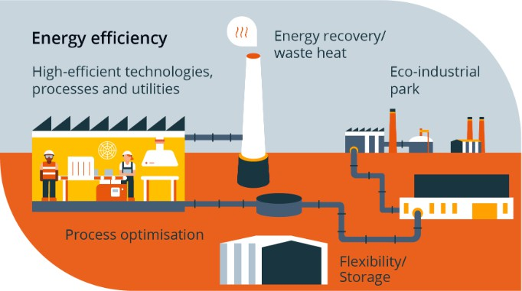

This diagram shows how industries conserve energy by using efficient machines, renewable energy sources, waste heat recovery, proper lighting systems, and energy monitoring. These methods help reduce energy consumption, lower operational costs, and improve industrial efficiency.

Energy-Efficient Technologies
Energy-efficient technologies refer to modern equipment and systems that help industries reduce energy consumption while maintaining productivity, quality, and safety. Industries use large amounts of energy for operating machines, lighting, heating, cooling, and production processes. By adopting energy-efficient technologies, industries can reduce energy wastage, lower operational costs, and improve overall efficiency.

One of the most commonly used technologies is energy-efficient electric motors. These motors consume less power and provide better performance compared to traditional motors. Variable Frequency Drives (VFDs) are also widely used to control the speed of motors according to load requirements, which helps in saving energy and increasing equipment life.

Modern lighting systems such as LED lights consume less electricity and provide better illumination than traditional lighting. Automated lighting controls further reduce energy consumption by switching off lights when not needed. Automation and control systems using sensors and monitoring software help industries track energy usage and operate machines efficiently.

Efficient heating and cooling technologies, such as improved boilers, furnaces, refrigeration systems, and insulation methods, also help reduce energy consumption. Waste heat recovery systems reuse heat generated from industrial processes, improving overall efficiency.

Renewable energy technologies like solar panels, wind energy, and biomass are increasingly used in industries to reduce dependence on conventional fuels and promote clean energy usage.

Thus, energy-efficient technologies help industries conserve energy, reduce costs, improve equipment performance, and support sustainable industrial development.
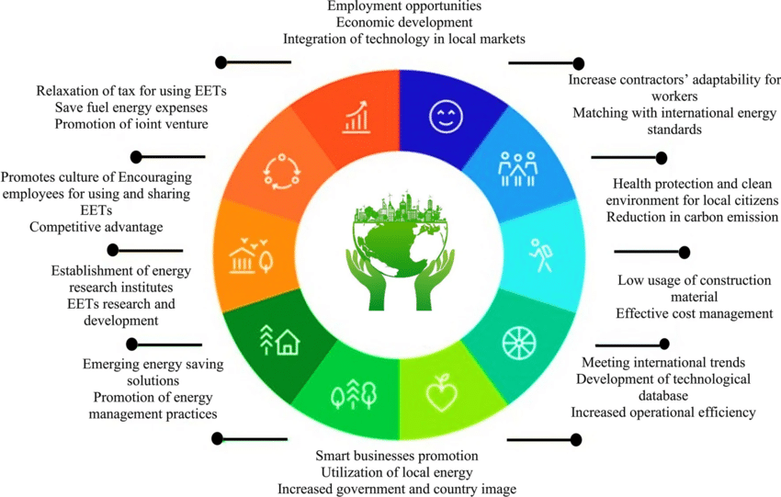

Renewable Energy In Industries
Renewable energy refers to energy obtained from natural sources that are continuously replenished and environmentally friendly, such as solar energy, wind energy, biomass, and hydropower. In modern industries, the use of renewable energy is increasing rapidly due to rising fuel costs, environmental concerns, and the need for sustainable development. Traditional sources of energy such as coal, diesel, and natural gas are limited and contribute to pollution, whereas renewable energy sources are clean, sustainable, and cost-effective in the long run.

Industries are adopting solar energy systems for generating electricity, heating water, and powering lighting systems. Solar panels installed on industrial rooftops help reduce dependence on grid electricity and lower energy costs. Wind energy is also used in certain industries to generate power where wind resources are available. Biomass energy, which is derived from agricultural and organic waste, is used in industries for heating and electricity generation. Hydropower is another renewable source used in industrial operations where water resources are accessible.

The adoption of renewable energy helps industries reduce carbon emissions, protect the environment, and improve their corporate image. It also ensures energy security by reducing dependence on fossil fuels. Although the initial investment in renewable energy technologies may be high, the long-term benefits in terms of cost savings, sustainability, and environmental protection make it an essential component of industrial energy management.

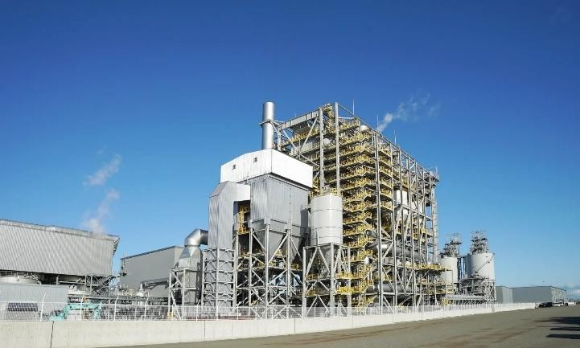
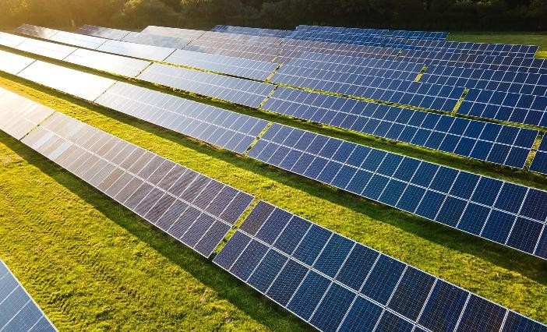
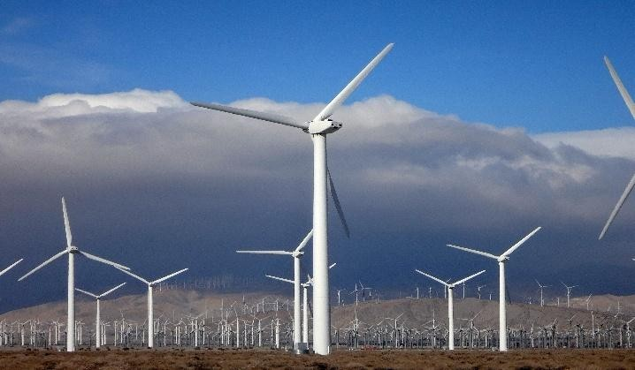
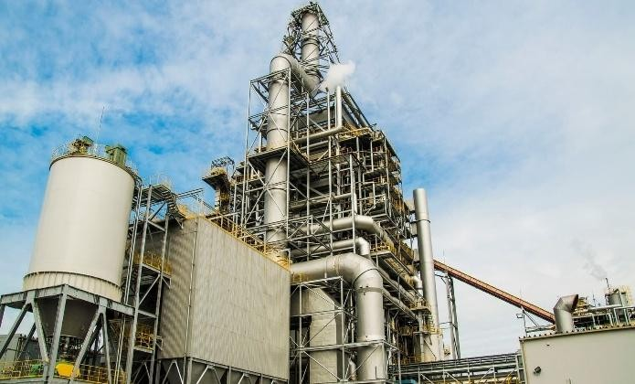

Role Of Energy Manager
An Energy Manager plays a crucial role in planning, implementing, and monitoring energy management activities in an industry. The main responsibility of an energy manager is to ensure efficient use of energy resources and reduce energy consumption without affecting productivity. Energy managers analyze energy usage patterns, identify areas of wastage, and implement energy-saving strategies.

They conduct energy audits, monitor equipment performance, and suggest improvements such as the adoption of energy-efficient technologies and renewable energy sources. Energy managers also ensure compliance with government energy regulations and environmental policies. They prepare reports on energy consumption and track progress toward energy-saving targets.

Another important responsibility of an energy manager is to create awareness among employees about energy conservation practices. Training programs and awareness campaigns help employees understand their role in reducing energy consumption. Thus, the energy manager acts as a key link between management, technical teams, and workers in achieving energy efficiency and sustainability.

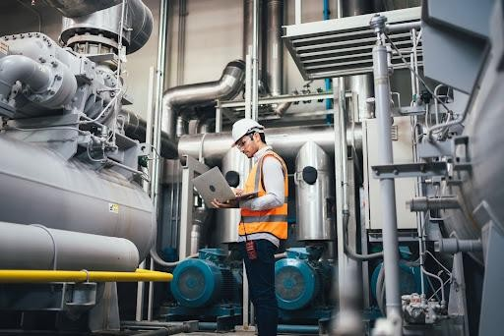

Energy Management System (ISO 50001)
ISO 50001 is an international standard developed for establishing, implementing, maintaining, and improving an Energy Management System (EnMS) in organizations. It provides a systematic approach for industries to monitor energy usage, improve efficiency, and reduce energy costs. The standard helps industries set energy policies, establish objectives, and develop action plans for energy conservation.

The ISO 50001 framework focuses on continuous improvement of energy performance through proper planning, monitoring, and control. It encourages industries to collect and analyze energy data, identify significant energy-consuming areas, and implement improvement measures. By following this standard, industries can ensure efficient use of energy resources and maintain consistency in energy management practices.

Implementation of ISO 50001 helps organizations reduce environmental impact, comply with regulations, and improve operational efficiency. It also enhances the reputation of industries by demonstrating their commitment to sustainability and responsible energy use.

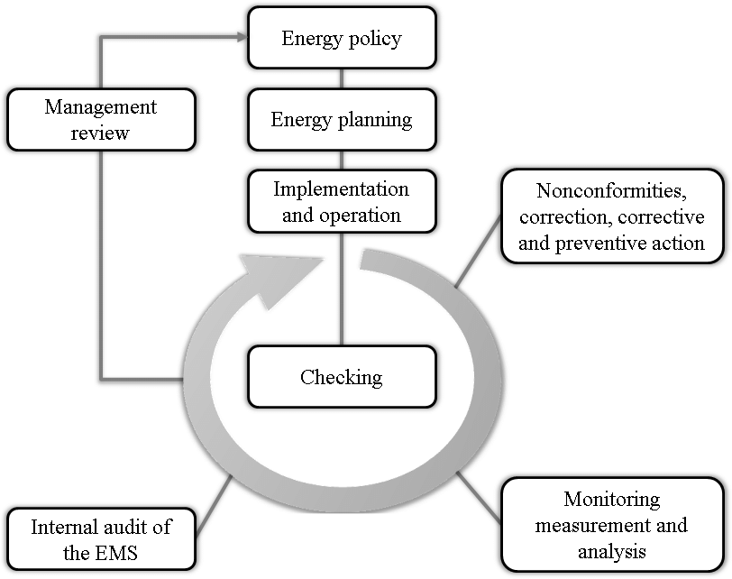

Government Policies and Regulations
Governments play an important role in promoting energy management and conservation in industries through various policies, laws, and regulations. These policies encourage industries to adopt energy-efficient practices and reduce environmental pollution. The Energy Conservation Act and guidelines issued by the Bureau of Energy Efficiency (BEE) promote the efficient use of energy in industrial sectors.

Many governments provide incentives, subsidies, and financial support for industries that adopt renewable energy technologies and energy-efficient equipment. Mandatory energy audits and performance standards are also implemented to ensure responsible energy usage. Environmental protection laws regulate emissions and encourage industries to minimize pollution.

These policies help create awareness about energy conservation and motivate industries to invest in sustainable technologies. Compliance with government regulations also improves industrial credibility and supports long-term growth.

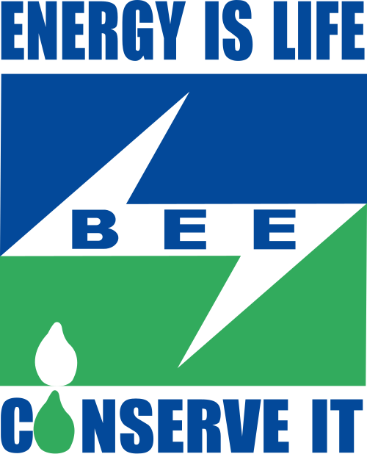

Case Study
A medium-scale manufacturing industry implemented an energy management program to reduce electricity consumption and improve operational efficiency. The industry conducted an energy audit and identified that a significant amount of energy was being wasted due to outdated motors, inefficient lighting systems, and poor maintenance practices.

The management decided to replace traditional lighting with LED systems, install energy- efficient motors, and implement a waste heat recovery system. Regular maintenance schedules were also introduced to improve equipment performance. Employees were trained to follow energy-saving practices and avoid unnecessary use of machines.

As a result, the industry achieved a noticeable reduction in energy consumption and operational costs. Productivity improved, equipment performance became more reliable, and environmental impact was reduced. This case demonstrates how proper energy management practices can bring significant benefits to industries.

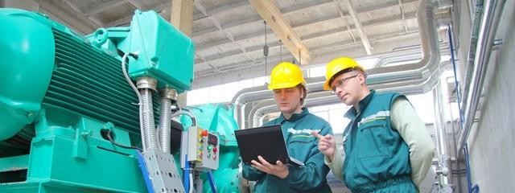

Advantages and Benefits of Energy Management
Energy management offers several benefits to industries by improving efficiency and reducing costs. It helps industries minimize energy wastage and optimize resource utilization. Reduced energy consumption leads to lower electricity and fuel bills, improving financial performance.

Energy management also enhances equipment efficiency and reduces maintenance costs. It supports environmental protection by reducing greenhouse gas emissions and pollution. Industries adopting energy management practices gain a competitive advantage in the market and improve their corporate image.

In addition, it promotes sustainable development by conserving natural resources and ensuring long-term industrial growth. Therefore, energy management is beneficial not only economically but also environmentally and socially.

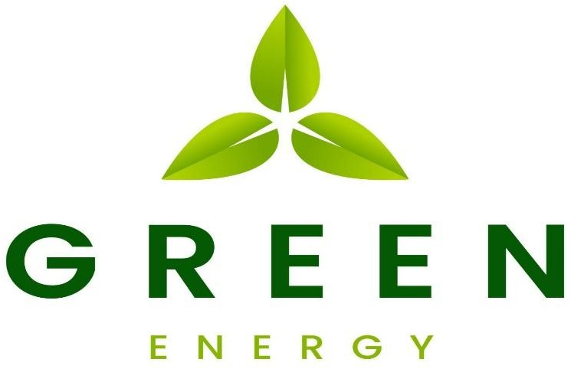

Challenges in Energy Management
Despite its benefits, industries face several challenges in implementing energy management practices. One of the major challenges is the high initial cost of installing energy-efficient technologies and renewable energy systems. Many industries hesitate to invest due to financial limitations.

Lack of awareness and technical knowledge among employees also affects the effective implementation of energy-saving measures. Resistance to change and dependency on traditional practices create difficulties in adopting modern technologies. In some cases, industries lack skilled professionals and proper monitoring systems.

Technological limitations and maintenance issues further complicate energy management efforts. Overcoming these challenges requires proper planning, training, financial support, and commitment from management.

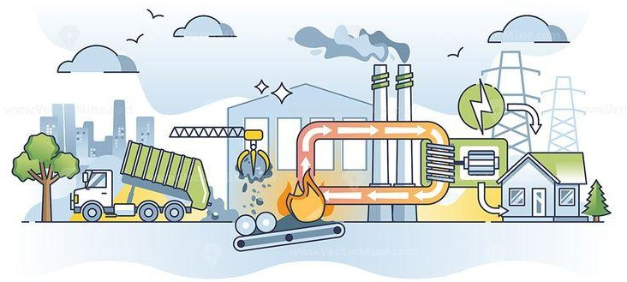

Conclusion & References
Energy Management in Industries plays a vital role in improving efficiency, reducing costs, and promoting sustainable development. With the increasing demand for energy and rising environmental concerns, industries must adopt systematic approaches to manage energy resources effectively. Proper planning, monitoring, and implementation of energy-saving techniques help industries reduce wastage and improve productivity.

The adoption of energy-efficient technologies, renewable energy sources, and energy management systems contributes to long-term economic and environmental benefits. It also ensures compliance with government regulations and enhances industrial competitiveness.

Thus, energy management is not only essential for cost reduction but also for environmental protection and sustainable industrial growth. Industries that adopt proper energy management practices are better prepared to face future energy challenges and achieve long-term success.

References
- Energy Management Handbook – Industrial Energy Conservation Guide
- Bureau of Energy Efficiency (BEE), Government of India publications
- ISO 50001 Energy Management System documentation
- Industrial Energy Management textbooks and study materials
- Government Energy Conservation Act and policy documents
- Research papers on industrial energy efficiency and conservation
- Online educational resources on renewable energy and energy management
- Technical articles on energy-efficient technologies used in industries
- Environmental and sustainability reports related to industrial energy use
- Academic notes and lecture materials on Energy Management in Industries

